**XML data**

|  |
| --- |
| school_ucla.xml |
| <?xml version="1.0" encoding="UTF-8"?> <school schoolName = "University of California, Los Angeles" schoolID = "ucla"  xmlns:xsi="http://www.w3.org/2001/XMLSchema-instance"  xsi:noNamespaceSchemaLocation="school.xsd">  <department departmentName="computer science" departmentID="cs">  <class ClassName="Operating Systems Principles" ClassID="cs 111"/>    <class ClassName="Computer Networks" ClassID="cs 118"/>    <class ClassName="Introduction to Computer Organization" ClassID="cs 33"/>    <class ClassName=" Logic Design of Digital Systems" ClassID="cs m51a"/>    </department>  <department departmentName="electrical engineering" departmentID="ee">  <class ClassName="Circuit Theory I" ClassID="EL ENGR 100-1,"/>   <class ClassName="Engineering Electromagnetics" ClassID="ee 101a"/>  <class ClassName="Electromagnetic Waves" ClassID="ee 101b"/>   </department>  <professor professorName = "Yahya Rahmat-Samii" professorID = "1002" email="rahmat@ee.ucla.edu" >  </professor>  <professor professorName = "JOSHI, C.J" professorID ="1003" email="cjoshi@ucla.edu" >   </professor>   </school> |

|  |
| --- |
| school.xml |
| <?xml version="1.0" encoding="UTF-8"?> <school schoolName = "San Jose State University" schoolID = "sjsu"  xmlns:xsi="http://www.w3.org/2001/XMLSchema-instance"  xsi:noNamespaceSchemaLocation="school.xsd">  <department departmentName="computer science" departmentID="cs">  <class ClassName="object oriented design" ClassID="cs 151"/>    <class ClassName="Programming Paradigms" ClassID="cs 152"/>    <class ClassName="Data Structures and Algorithms" ClassID="cs 146"/>    <class ClassName="Software Engineering" ClassID="cs 160"/>    </department>  <department departmentName="software engineering" departmentID="se">  <class ClassName="object oriented design" ClassID="se 151"/>   <class ClassName="Senior Design Project I" ClassID="se 195a"/>  <class ClassName="Data Structures and Algorithms" ClassID="se 146"/>   <class ClassName="Software Engineering" ClassID="se 195b"/>   </department>  <professor professorName = "Ronald Mak" professorID = "10000" email="ron.mak@sjsu.edu" >  </professor>  <professor professorName = "Rula Khayrallah" professorID ="10001" email="rula.khayrallah@sjsu.edu" >   </professor>  </school> |

|  |
| --- |
| htmlschool.xml |
| <?xml version="1.0" encoding="UTF-8"?>  <department xmlns:xsi="http://www.w3.org/2001/XMLSchema-instance"  xsi:noNamespaceSchemaLocation="htmlschool.xsd">    <professor gender="male">  <professorName>Ronald Mak</professorName>  <professorEmail>ron.mak@sjsu.edu</professorEmail>  </professor>    <professor gender="female">  <professorName>Suneuy Kim</professorName>  <professorEmail>suneuy.kim@sjsu.edu</professorEmail>  </professor>    <professor gender="male">  <professorName>Cay Horstmann</professorName>  <professorEmail>cay.horstmann@sjsu.edu</professorEmail>  </professor>    <professor gender="female">  <professorName>Anna Meng</professorName>  <professorEmail>hsin-yi.meng@sjsu.edu</professorEmail>  </professor>  </department> |

**XML schema**

|  |
| --- |
| school.xsd |
| <?xml version="1.0" encoding="UTF-8"?> <xs:schema xmlns:xs="http://www.w3.org/2001/XMLSchema">  <xs:element name="class" type="Class_type"/>  <xs:complexType name="Class_type">   <xs:attribute name="ClassName" type="xs:string"/>  <xs:attribute name="ClassID" type="xs:string"/>  </xs:complexType>    <xs:element name="professor" type="Professor_type"/>  <xs:complexType name="Professor_type">   <xs:simpleContent>  <xs:extension base="xs:string">  <xs:attribute name="professorName" type="xs:string" />  <xs:attribute name="professorID" type="xs:integer" />  <xs:attribute name="email" type="xs:integer" />  </xs:extension>  </xs:simpleContent>  </xs:complexType>    <xs:element name="department" type="department_type"/>  <xs:complexType name="department_type">  <xs:sequence>  <xs:element ref="class" minOccurs="0" maxOccurs="unbounded"/>  </xs:sequence>  <xs:attribute name="departmentCode" type="xs:string"/>  <xs:attribute name="departmentID" type="xs:string"/>  </xs:complexType>    <xs:element name="school" type="school_type"/>  <xs:complexType name="school_type">  <xs:sequence>  <xs:element ref="department" minOccurs="0" maxOccurs="unbounded"/>  <xs:element ref="professor" minOccurs="0" maxOccurs="unbounded"/>  </xs:sequence>  <xs:attribute name="schoolName" type="xs:string"/>  <xs:attribute name="schoolID" type="xs:string"/>  </xs:complexType>  </xs:schema> |

|  |
| --- |
| htmlschool.xsd |
| <?xml version="1.0" encoding="UTF-8"?> <xs:schema xmlns:xs="http://www.w3.org/2001/XMLSchema" elementFormDefault="qualified">  <xs:complexType name="professor_type">  <xs:sequence>  <xs:element name="professorName" type="xs:string"/>  <xs:element name="professorEmail" type="xs:string"/>  </xs:sequence>    <xs:attribute name="gender">  <xs:simpleType>  <xs:restriction base="xs:string">  <xs:enumeration value="male"/>  <xs:enumeration value="female"/>  </xs:restriction>  </xs:simpleType>  </xs:attribute>  </xs:complexType>  <xs:element name="professor" type="professor_type"></xs:element>  <xs:complexType name="department_type">  <xs:sequence>  <xs:element ref="professor" minOccurs="0" maxOccurs="unbounded"></xs:element>  </xs:sequence>  </xs:complexType>  <xs:element name="department" type="department_type"></xs:element> </xs:schema> |

**XQuery FLWOR expressions**

Xquery 1: return all the class under “software engineering” department

for $department in

doc("school.xml")

//department

let $d := $department

where

contains($d/@departmentName, "software engineering")

order by $d

return $d/class

Xquery 2: return all the class under “cs” department inside a school

for $department in

doc("school.xml")

//department

let $d := $department

where

contains($d/@departmentID, "cs")

order by $d

return <school>{$d/class} </school>

Xquery 3: return all the professors of sjsu inside school

for $school in

doc("school.xml")

//school

let $s := $school

where

contains($s/@schoolID, "sjsu")

order by $s

return <school> {$s/professor} </school>

Xquery 4: return professor whose ID is 10000

for $professor in

doc("school.xml")

//professor

let $p := $professor

where

contains($p/@professorID, "10000")

order by $p

return $p

Xquery 5: return the class “se 151”

for $class in

doc("school.xml")

//class

let $c := $class

where

contains($c/@ClassID, "se 151")

order by $c

return $c

Xquery 6: return the common departments of school and school_ucla

for $department in

*doc*("school.xml")

//department

for $departmentla

in *doc*("school_ucla.xml")

// department

let $d := $department,

$dla := $departmentla

where

$d/*@departmentName* = $dla/*@departmentName*

order by $d

return $d/class

Xquery 7: return the all the unique teachers from school and school_ucla

for $professor in

*doc*("school.xml")

//professor

for $professorla

in *doc*("school_ucla.xml")

// professor

let $p := $professor,

$pla := $professorla

where

$p/*@professorName* != $pla/*@professorName*

order by $p

return $p

Xquery 8 : return the professor Name from the list of htmlschool.xml

xquery version "1.0";

for $professor in *doc*("htmlschool.xml")

//professor

return $professor/professorName

Xquery 9 return the professor Name & Email from the list of htmlschool.xml

xquery version "1.0";

for $professor in *doc*("htmlschool.xml")

//professor

return <professor>{$professor/professorName, $professor/professorEmail}</professor>

Xquery 10 : return the professor Name by adding prefix based on the gender

**for** **$professor** **in**

*doc*("htmlschool.xml")

//**professor**

**return**(

<individual>

{

<title>

{

**if**(**$professor**/***@gender***="male")

**then** "Mr."

**else** "Ms."

}

</title>

,

**$professor**/**professorName**

}

</individual>

)

XQuery 11: return the professor Name by using 2 FLWOR expressions with output

**for** **$professor1** **in** *doc*("htmlschool.xml")

//**professor**

**for** **$professor2** **in**

*doc*("school.xml")

//**professor**

**let** **$p** := **$professor2**,

**$p1** := **$professor1**

**where**

**$p**/***@professorName*** = **$p1**/**professorName**

**return**

<Result>

{

(**$p**/***@professorID***,**$p**/***@professorName***,**$p1**/***@gender***,**$p**/***@email***)

}

</Result>

XQuery 12: html: show all the professor's’ names in htmlschool

<ul>

{

**for** **$x** **in** *doc*("htmlschool.xml")//**professor**//**professorName**

**order by** **$x**

**return** <li>{**$x**}</li>

}

</ul>

Text files of the output of your FLWOR expressions.

Query1 Output:

<?xml version="1.0" encoding="UTF-8"?>

<class xmlns:xsi="http://www.w3.org/2001/XMLSchema-instance"

ClassName="object oriented design"

ClassID="se 151"/>

<class xmlns:xsi="http://www.w3.org/2001/XMLSchema-instance"

ClassName="Senior Design Project I"

ClassID="se 195a"/>

<class xmlns:xsi="http://www.w3.org/2001/XMLSchema-instance"

ClassName="Data Structures and Algorithms"

ClassID="se 146"/>

<class xmlns:xsi="http://www.w3.org/2001/XMLSchema-instance"

ClassName="Software Engineering"

ClassID="se 195b"/>

Query2 Output:

<?xml version="1.0" encoding="UTF-8"?>

<school>

<department xmlns:xsi="http://www.w3.org/2001/XMLSchema-instance"

departmentName="computer science"

departmentID="cs">

<class ClassName="object oriented design" ClassID="cs 151"/>

<class ClassName="Programming Paradigms" ClassID="cs 152"/>

<class ClassName="Data Structures and Algorithms" ClassID="cs 146"/>

<class ClassName="Software Engineering" ClassID="cs 160"/>

</department>

<department xmlns:xsi="http://www.w3.org/2001/XMLSchema-instance"

departmentName="software engineering"

departmentID="se">

<class ClassName="object oriented design" ClassID="se 151"/>

<class ClassName="Senior Design Project I" ClassID="se 195a"/>

<class ClassName="Data Structures and Algorithms" ClassID="se 146"/>

<class ClassName="Software Engineering" ClassID="se 195b"/>

</department>

</school>

Query3 Output:

<school>

<professor xmlns:xsi="http://www.w3.org/2001/XMLSchema-instance"

professorName="Ronald Mak"

professorID="10000"

email="ron.mak@sjsu.edu">

</professor>

<professor xmlns:xsi="http://www.w3.org/2001/XMLSchema-instance"

professorName="Rula Khayrallah"

professorID="10001"

email="rula.khayrallah@sjsu.edu">

</professor>

</school>

Query4 Output:

<?xml version="1.0" encoding="UTF-8"?>

<professor xmlns:xsi="http://www.w3.org/2001/XMLSchema-instance"

professorName="Ronald Mak"

professorID="10000"

email="ron.mak@sjsu.edu">

</professor>

Query5 Output:

<?xml version="1.0" encoding="UTF-8"?>

<class xmlns:xsi="http://www.w3.org/2001/XMLSchema-instance"

ClassName="object oriented design"

ClassID="se 151"/>

Query6 Output :

<?xml version="1.0" encoding="UTF-8"?>

<class xmlns:xsi="http://www.w3.org/2001/XMLSchema-instance"

ClassName="object oriented design"

ClassID="cs 151"/>

<class xmlns:xsi="http://www.w3.org/2001/XMLSchema-instance"

ClassName="Programming Paradigms"

ClassID="cs 152"/>

<class xmlns:xsi="http://www.w3.org/2001/XMLSchema-instance"

ClassName="Data Structures and Algorithms"

ClassID="cs 146"/>

<class xmlns:xsi="http://www.w3.org/2001/XMLSchema-instance"

ClassName="Software Engineering"

ClassID="cs 160"/>

Query7 Output :

<?xml version="1.0" encoding="UTF-8"?>

<professor xmlns:xsi="http://www.w3.org/2001/XMLSchema-instance"

professorName="Ronald Mak"

professorID="10000"

email="ron.mak@sjsu.edu">

</professor>

<professor xmlns:xsi="http://www.w3.org/2001/XMLSchema-instance"

professorName="Ronald Mak"

professorID="10000"

email="ron.mak@sjsu.edu">

</professor>

<professor xmlns:xsi="http://www.w3.org/2001/XMLSchema-instance"

professorName="Rula Khayrallah"

professorID="10001"

email="rula.khayrallah@sjsu.edu">

</professor>

<professor xmlns:xsi="http://www.w3.org/2001/XMLSchema-instance"

professorName="Rula Khayrallah"

professorID="10001"

email="rula.khayrallah@sjsu.edu">

</professor>

Query8 Output:

<?xml version="1.0" encoding="UTF-8"?>

<professorName xmlns:xsi="http://www.w3.org/2001/XMLSchema-instance">Ronald Mak</professorName>

<professorName xmlns:xsi="http://www.w3.org/2001/XMLSchema-instance">Suneuy Kim</professorName>

<professorName xmlns:xsi="http://www.w3.org/2001/XMLSchema-instance">Cay Horstmann</professorName>

<professorName xmlns:xsi="http://www.w3.org/2001/XMLSchema-instance">Anna Meng</professorName>

Query 9 Output:

<?xml version="1.0" encoding="UTF-8"?>

<professor>

<professorName xmlns:xsi="http://www.w3.org/2001/XMLSchema-instance">Ronald Mak</professorName>

<professorEmail xmlns:xsi="http://www.w3.org/2001/XMLSchema-instance">ron.mak@sjsu.edu</professorEmail>

</professor>

<professor>

<professorName xmlns:xsi="http://www.w3.org/2001/XMLSchema-instance">Suneuy Kim</professorName>

<professorEmail xmlns:xsi="http://www.w3.org/2001/XMLSchema-instance">suneuy.kim@sjsu.edu</professorEmail>

</professor>

<professor>

<professorName xmlns:xsi="http://www.w3.org/2001/XMLSchema-instance">Cay Horstmann</professorName>

<professorEmail xmlns:xsi="http://www.w3.org/2001/XMLSchema-instance">cay.horstmann@sjsu.edu</professorEmail>

</professor>

<professor>

<professorName xmlns:xsi="http://www.w3.org/2001/XMLSchema-instance">Anna Meng</professorName>

<professorEmail xmlns:xsi="http://www.w3.org/2001/XMLSchema-instance">hsin-yi.meng@sjsu.edu</professorEmail>

</professor>

Query 10 Output

<?xml version="1.0" encoding="UTF-8"?>

<individual>

<title>Mr.</title>

<professorName xmlns:xsi="http://www.w3.org/2001/XMLSchema-instance">Ronald Mak</professorName>

</individual>

<individual>

<title>Ms.</title>

<professorName xmlns:xsi="http://www.w3.org/2001/XMLSchema-instance">Suneuy Kim</professorName>

</individual>

<individual>

<title>Mr.</title>

<professorName xmlns:xsi="http://www.w3.org/2001/XMLSchema-instance">Cay Horstmann</professorName>

</individual>

<individual>

<title>Ms.</title>

<professorName xmlns:xsi="http://www.w3.org/2001/XMLSchema-instance">Anna Meng</professorName>

</individual>

XQuery11:

<?xml version="1.0" encoding="UTF-8"?>

<Result professorID="10000"

professorName="Ronald Mak"

gender="male"

email="ron.mak@sjsu.edu"/>

XQuery12:

<?xml version="1.0" encoding="UTF-8"?>

<ul>

<li>

<professorName xmlns:xsi="http://www.w3.org/2001/XMLSchema-instance">Anna Meng</professorName>

</li>

<li>

<professorName xmlns:xsi="http://www.w3.org/2001/XMLSchema-instance">Cay Horstmann</professorName>

</li>

<li>

<professorName xmlns:xsi="http://www.w3.org/2001/XMLSchema-instance">Ronald Mak</professorName>

</li>

<li>

<professorName xmlns:xsi="http://www.w3.org/2001/XMLSchema-instance">Suneuy Kim</professorName>

</li>

</ul

**Oxygen editor screen shots of the FLWOR expressions and results**

Query 1:

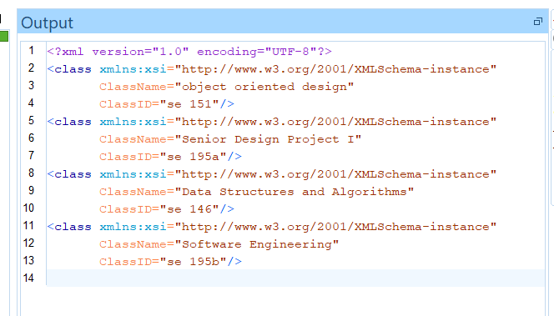

Quey 2:

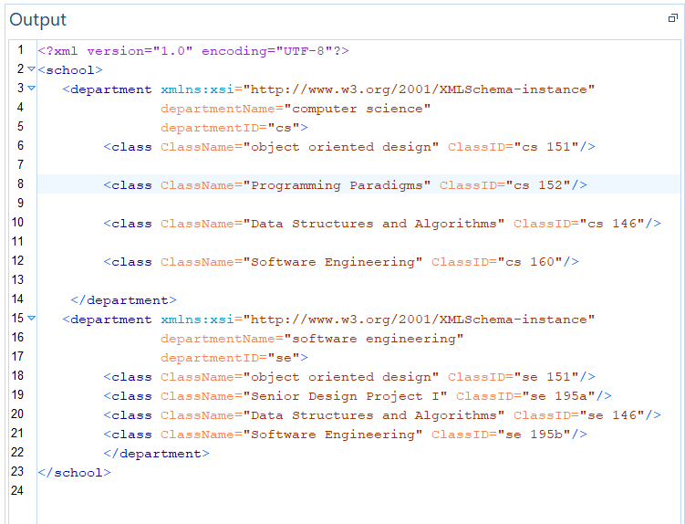

Query 3:

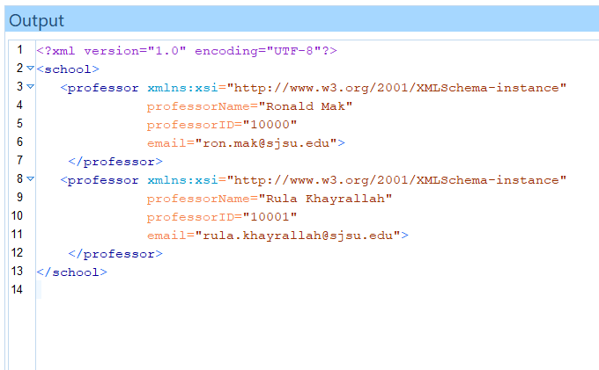

Query 4:

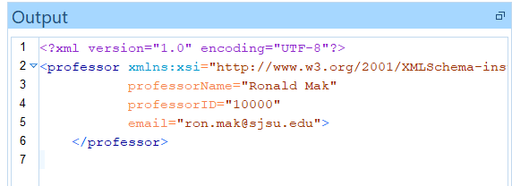

Query 5:

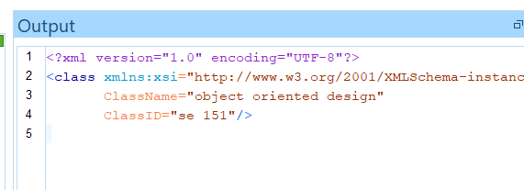

Query 6:

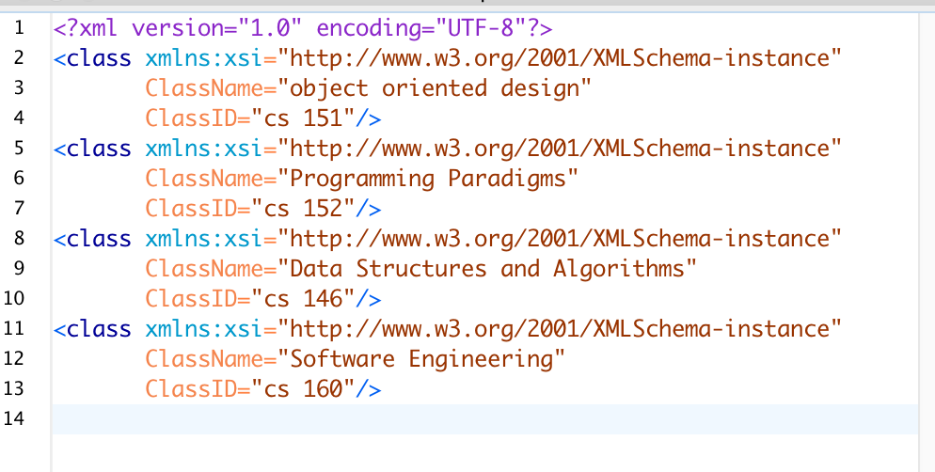

Query 7:

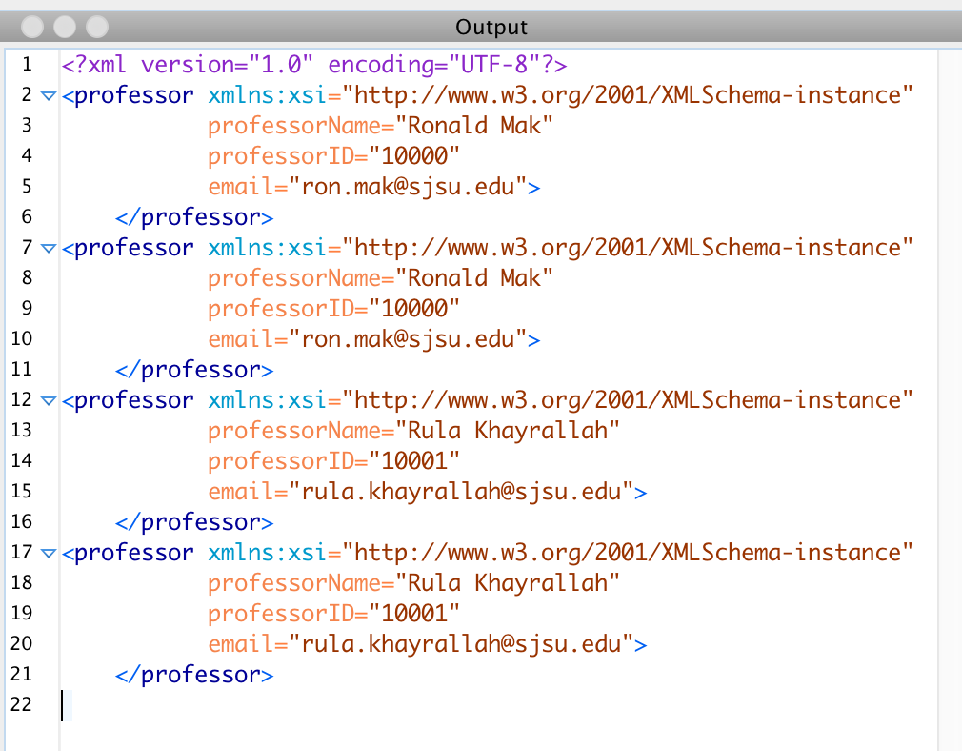

Xquery 8:

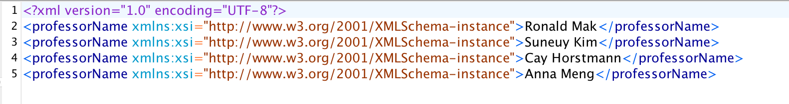

Xquery 9:

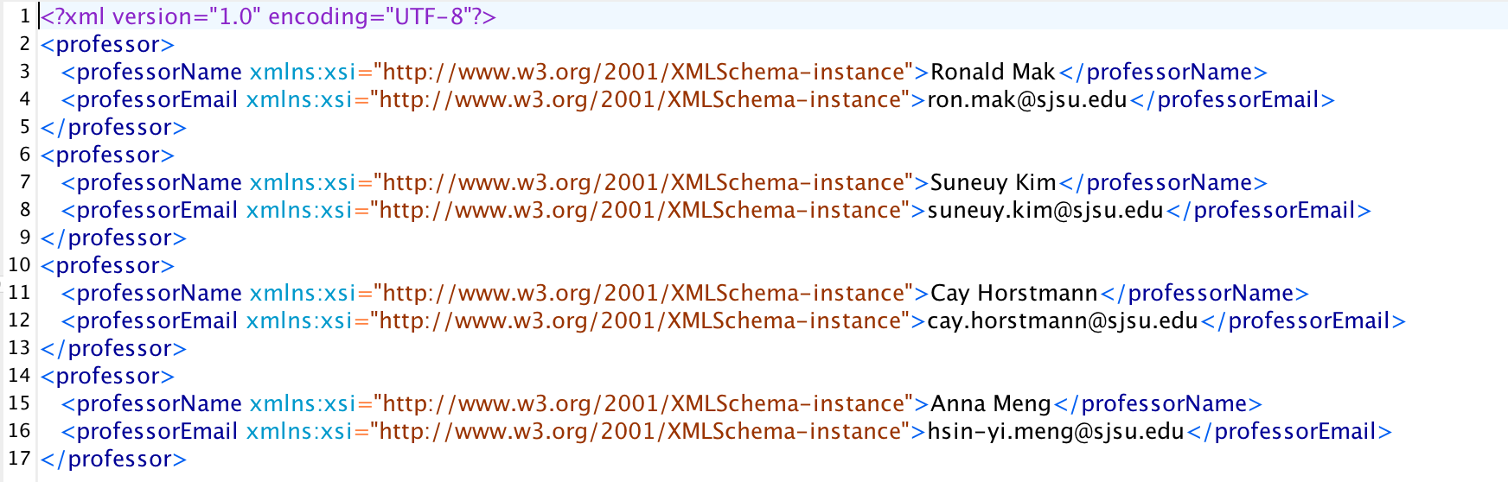

Xquery 10:

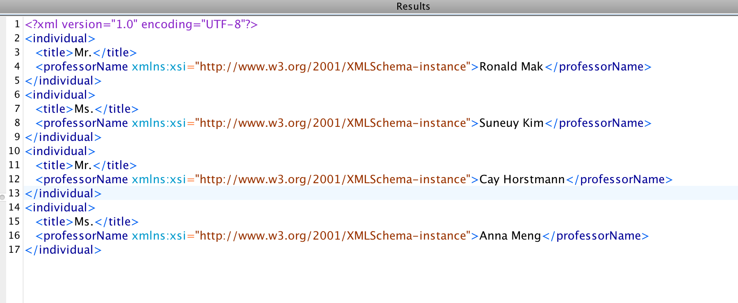

XQUERY 11

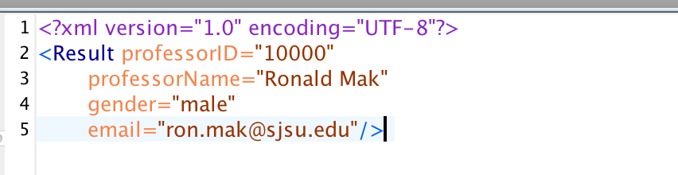

XQUERY 12

